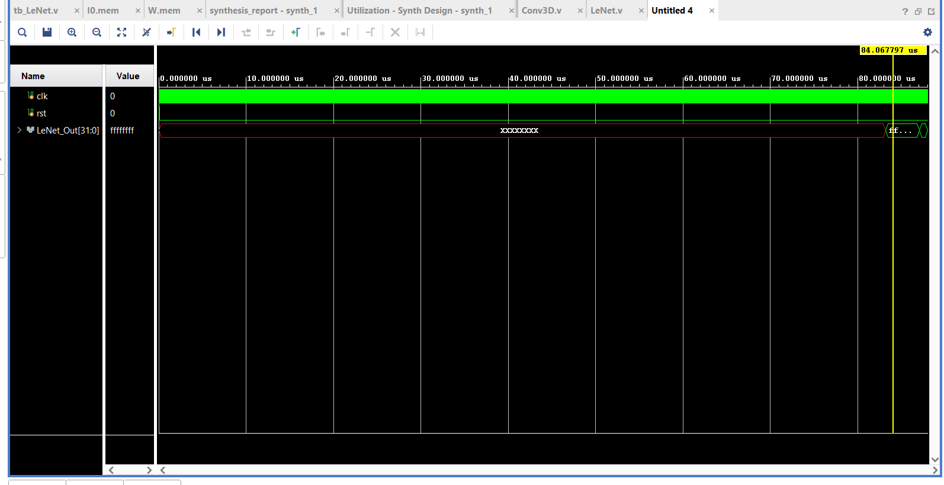

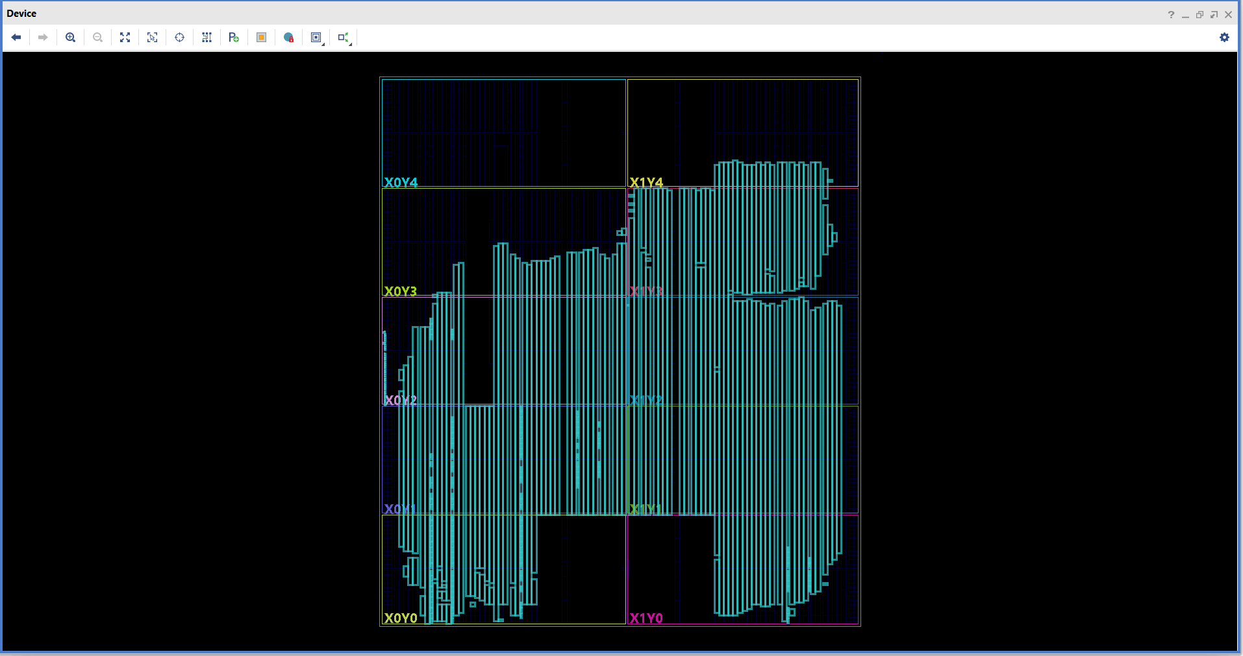

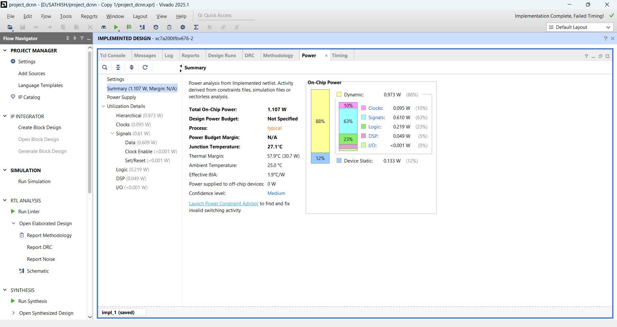

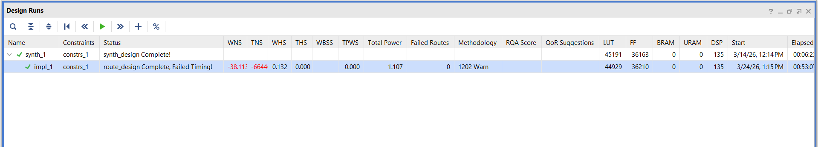

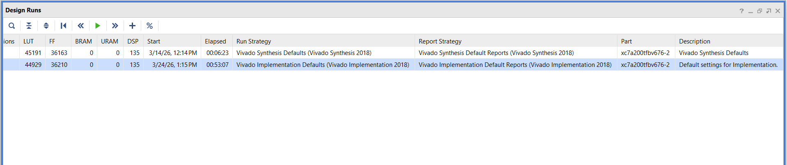

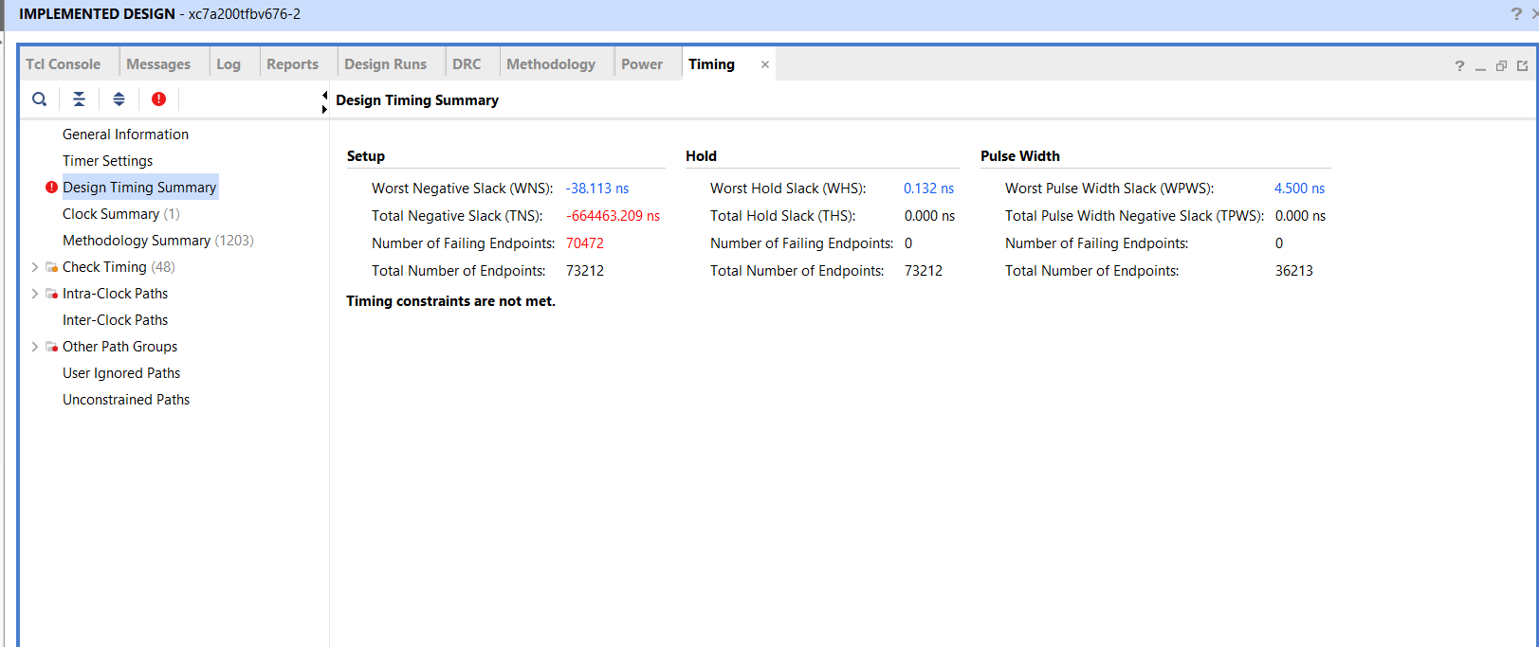

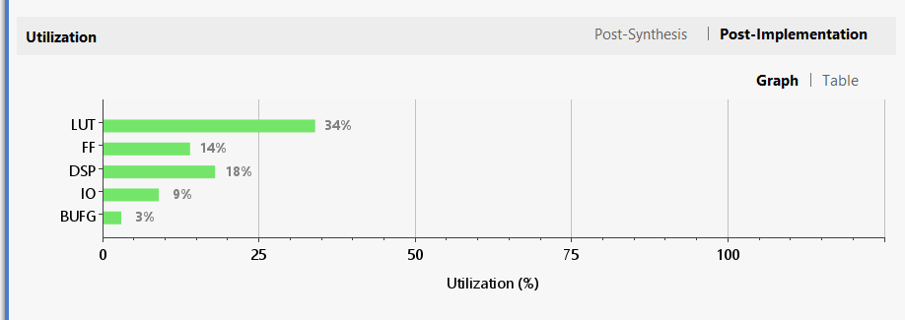

====================================
Python CNN Testing (Reference)
====================================
Test 0 : Expected=7 | Predicted=7
Test 1 : Expected=2 | Predicted=2
Test 2 : Expected=1 | Predicted=1
Test 3 : Expected=0 | Predicted=0
Test 4 : Expected=4 | Predicted=4
Test 5 : Expected=1 | Predicted=1
Test 6 : Expected=4 | Predicted=4
Test 7 : Expected=9 | Predicted=9
Test 8 : Expected=5 | Predicted=5
Test 9 : Expected=9 | Predicted=9
Test 10 : Expected=0 | Predicted=0
Test 11 : Expected=6 | Predicted=6
Test 12 : Expected=9 | Predicted=9
Test 13 : Expected=0 | Predicted=0
Test 14 : Expected=1 | Predicted=1
Test 15 : Expected=5 | Predicted=5
Test 16 : Expected=9 | Predicted=9
Test 17 : Expected=7 | Predicted=7
Test 18 : Expected=3 | Predicted=3
Test 19 : Expected=4 | Predicted=4
Test 20 : Expected=9 | Predicted=9
Test 21 : Expected=6 | Predicted=6
Test 22 : Expected=6 | Predicted=6
Test 23 : Expected=5 | Predicted=5
Test 24 : Expected=4 | Predicted=4
Test 25 : Expected=0 | Predicted=0
Test 26 : Expected=7 | Predicted=7
Test 27 : Expected=4 | Predicted=4
Test 28 : Expected=0 | Predicted=0
Test 29 : Expected=1 | Predicted=1
Test 30 : Expected=3 | Predicted=3
Test 31 : Expected=1 | Predicted=1
Test 32 : Expected=3 | Predicted=3
Test 33 : Expected=4 | Predicted=4
Test 34 : Expected=7 | Predicted=7
Test 35 : Expected=2 | Predicted=2
Test 36 : Expected=7 | Predicted=7
Test 37 : Expected=1 | Predicted=1
Test 38 : Expected=2 | Predicted=2
Test 39 : Expected=1 | Predicted=1
Test 40 : Expected=1 | Predicted=1
Test 41 : Expected=7 | Predicted=7
Test 42 : Expected=4 | Predicted=4
Test 43 : Expected=2 | Predicted=2
Test 44 : Expected=3 | Predicted=3
Test 45 : Expected=5 | Predicted=5
Test 46 : Expected=1 | Predicted=1
Test 47 : Expected=2 | Predicted=5
Test 48 : Expected=4 | Predicted=4
Test 49 : Expected=4 | Predicted=4
Test 50 : Expected=6 | Predicted=6
Test 51 : Expected=3 | Predicted=3
Test 52 : Expected=5 | Predicted=5
Test 53 : Expected=5 | Predicted=5
Test 54 : Expected=6 | Predicted=6
Test 55 : Expected=0 | Predicted=0
Test 56 : Expected=4 | Predicted=4
Test 57 : Expected=1 | Predicted=1
Test 58 : Expected=9 | Predicted=0
Test 59 : Expected=5 | Predicted=5
Test 60 : Expected=7 | Predicted=7
Test 61 : Expected=8 | Predicted=8
Test 62 : Expected=9 | Predicted=9
Test 63 : Expected=3 | Predicted=3
Test 64 : Expected=7 | Predicted=7
Test 65 : Expected=4 | Predicted=4
Test 66 : Expected=6 | Predicted=6
Test 67 : Expected=4 | Predicted=4
Test 68 : Expected=3 | Predicted=3
Test 69 : Expected=0 | Predicted=0
Test 70 : Expected=7 | Predicted=7
Test 71 : Expected=0 | Predicted=0
Test 72 : Expected=2 | Predicted=2
Test 73 : Expected=9 | Predicted=9
Test 74 : Expected=1 | Predicted=1
Test 75 : Expected=7 | Predicted=9
Test 76 : Expected=3 | Predicted=3
Test 77 : Expected=2 | Predicted=2
Test 78 : Expected=9 | Predicted=9
Test 79 : Expected=7 | Predicted=2
Test 80 : Expected=7 | Predicted=7
Test 81 : Expected=6 | Predicted=6
Test 82 : Expected=2 | Predicted=2
Test 83 : Expected=7 | Predicted=7
Test 84 : Expected=8 | Predicted=8
Test 85 : Expected=4 | Predicted=4
Test 86 : Expected=7 | Predicted=7
Test 87 : Expected=3 | Predicted=3
Test 88 : Expected=6 | Predicted=6
Test 89 : Expected=1 | Predicted=1
Test 90 : Expected=3 | Predicted=3
Test 91 : Expected=6 | Predicted=6
Test 92 : Expected=9 | Predicted=9
Test 93 : Expected=3 | Predicted=3
Test 94 : Expected=1 | Predicted=1
Test 95 : Expected=4 | Predicted=4
Test 96 : Expected=1 | Predicted=1
Test 97 : Expected=7 | Predicted=7
Test 98 : Expected=6 | Predicted=6
Test 99 : Expected=9 | Predicted=9
====================================
Total Tests = 100
Correct = 98
Accuracy = 98.00%
digit .mem, labels .mem, weights .mem, conv1.mem created (FC layer)
====================================
ALL FILES GENERATED SUCCESSFULLY
====================================

